2a). Adding Raster Layers.

Step 1: Go to Layer → Add Layer → Add Raster Layer. Then go to Practical 2 → A → Data\gl_gpwv3_pdens_90_ascii_one\glds90ag60.asc
Data\gl_gpwv3_pdens_90_ascii_one\glds00ag60.asc

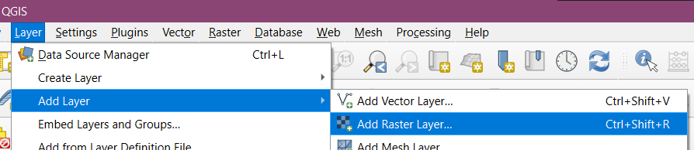

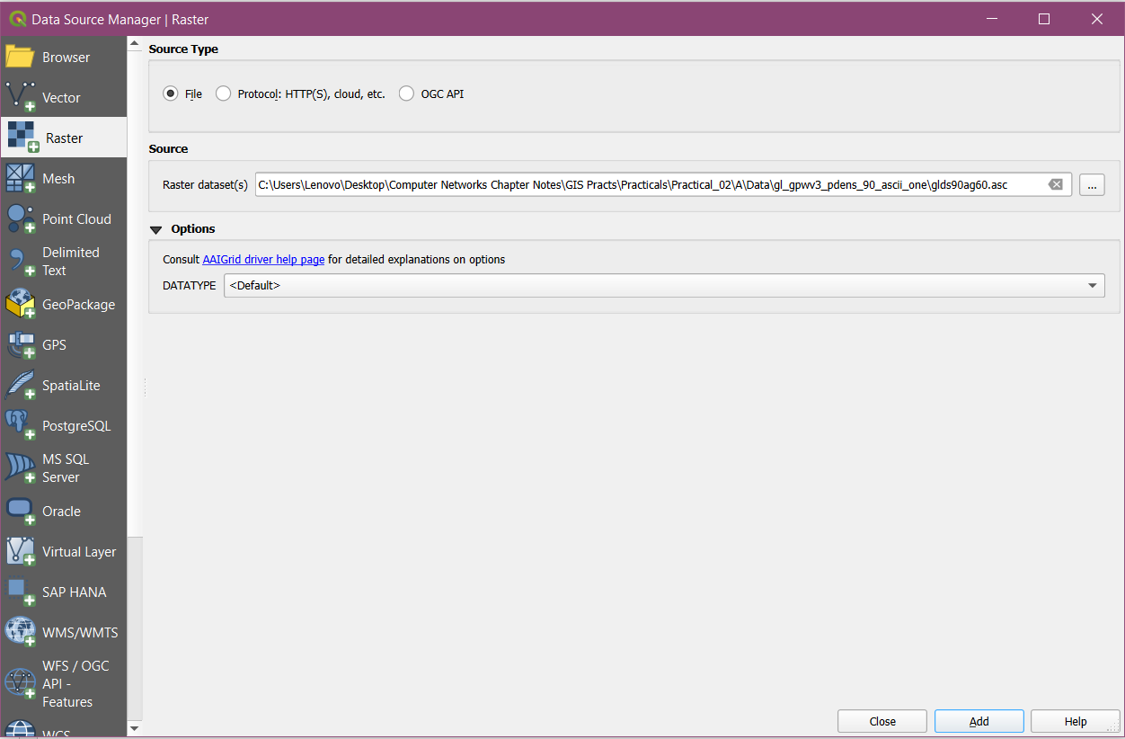

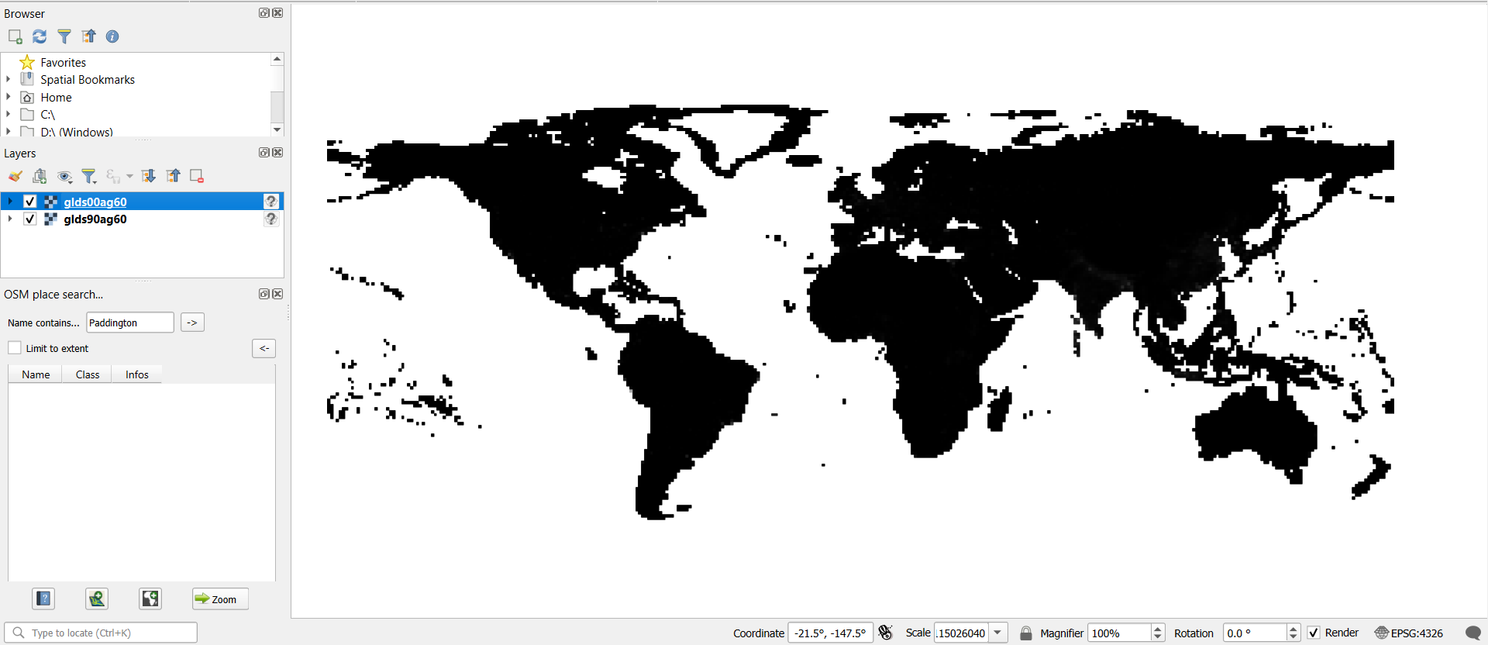

2b). Raster Styling and Analysis.

Step 1: To start with analysis of population data, convert the pixel from grayscale to Color.
Select “glds90ag60.asc” Layer form layer Pane → select property OR double click on it. Perform the following and change to appropriate settings. Apply and then repeat for “glds00ag60.asc” layer.

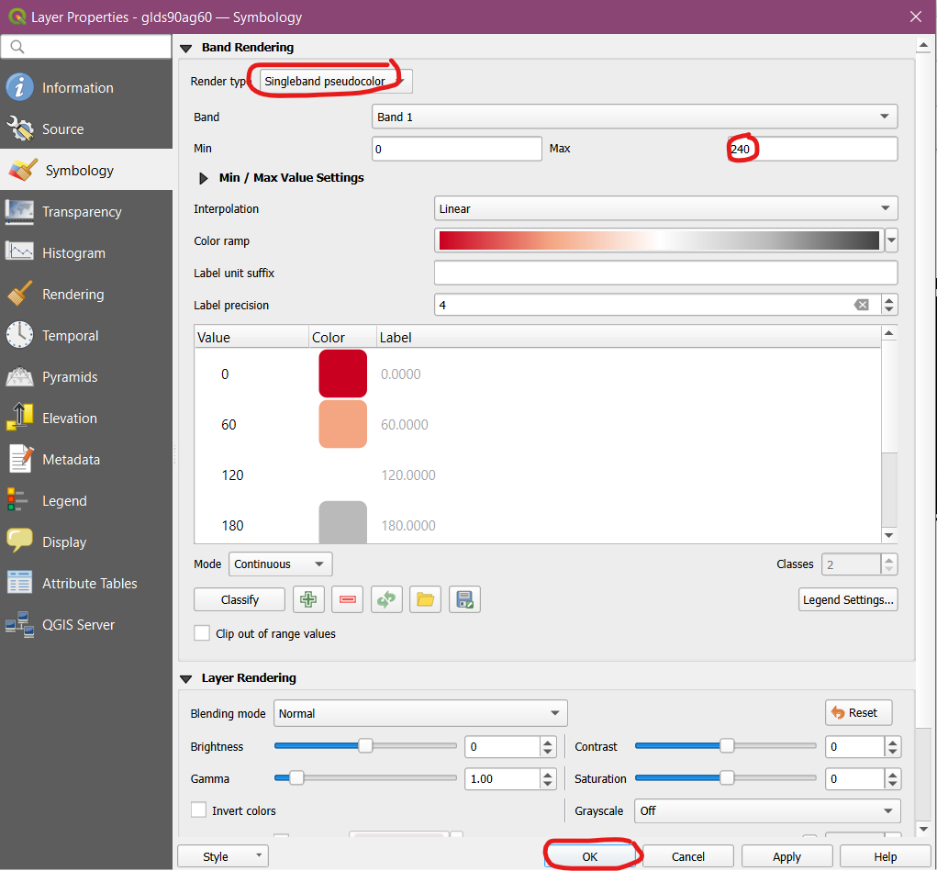
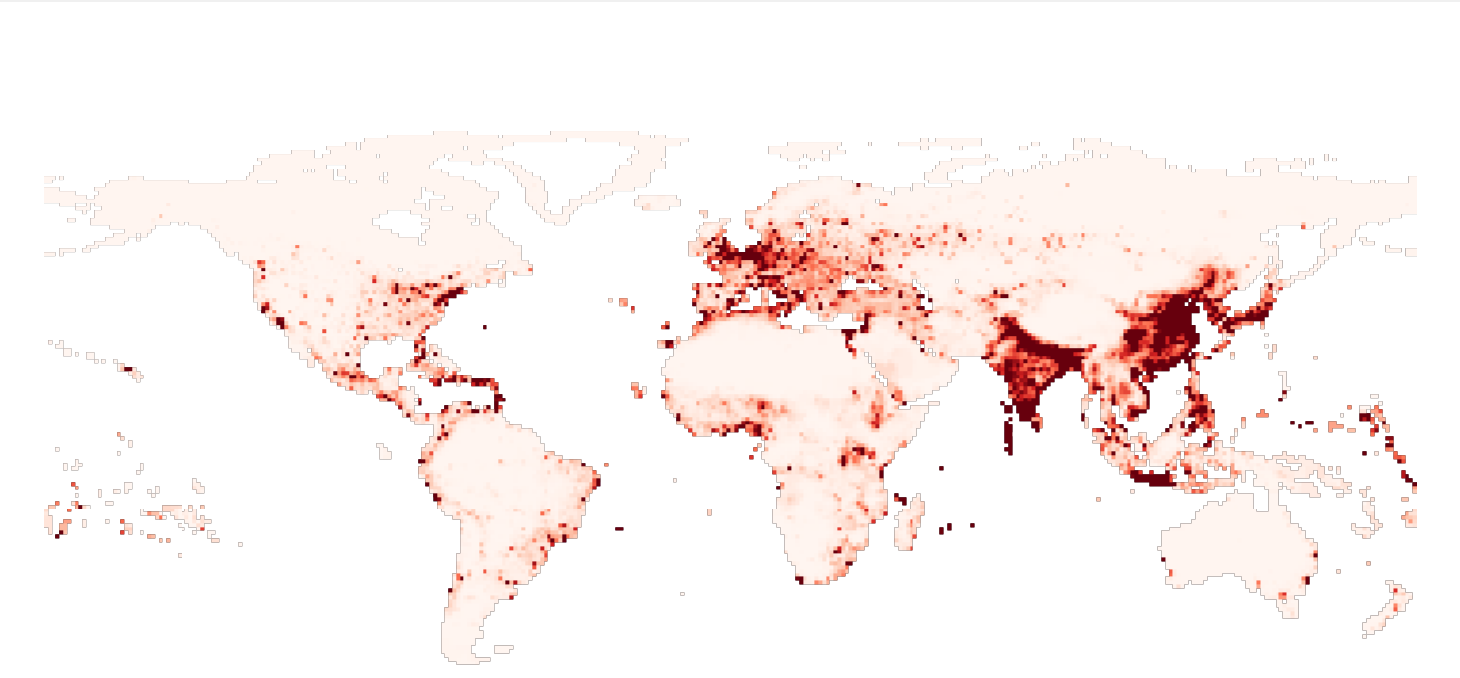

Step 2: The objective this experiment is to analyze raster data, as an example we will find areas with largest population change between 1990 and 2000, by calculating the difference between each pixel values. Go to Raster → Raster Calculator. Put the expression “glds00ag60@1” - “glds90ag60@1”.

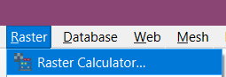
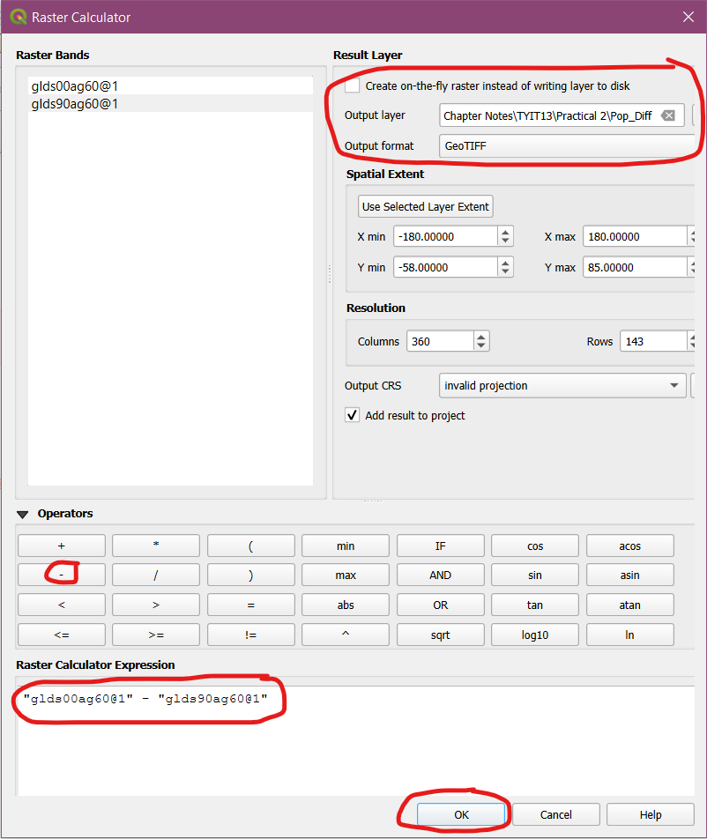
Step 3: Remove all the other layers so that the Pop_Diff Layer is shown. Then go to symbology and then perform the following operations.

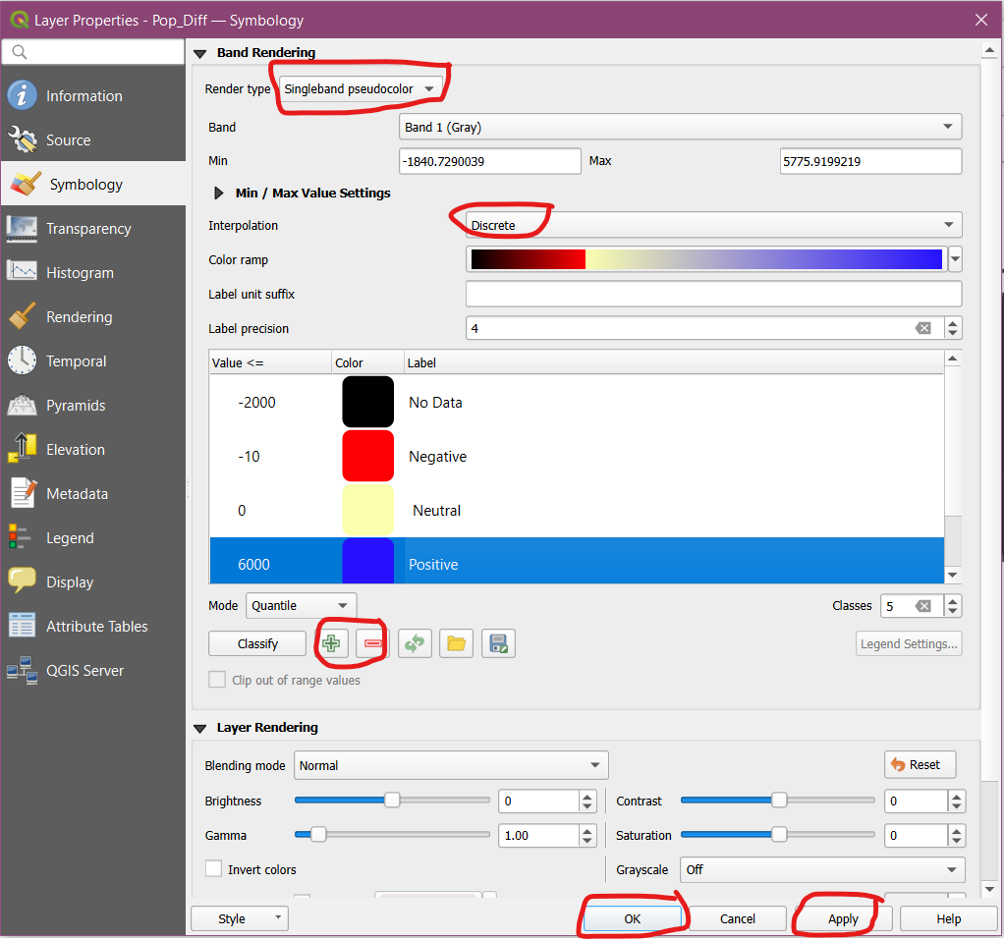

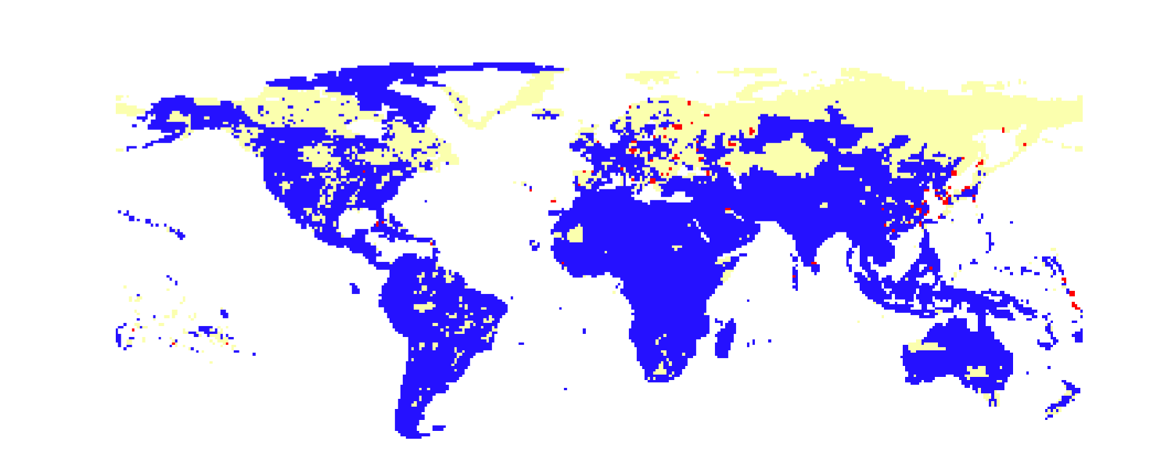

2c). Raster Mosaicking and Clipping.

Step 1: Go to Layer → Add Layer → Add Raster Layer. Then select the following from the Practical 2C Folder:
FAS_India1.2018349.terra.367.2km.tif
FAS_India2.2018349.terra.367.2km.tif
FAS_India3.2018349.terra.367.2km.tif
FAS_India4.2018349.terra.367.2km.tif

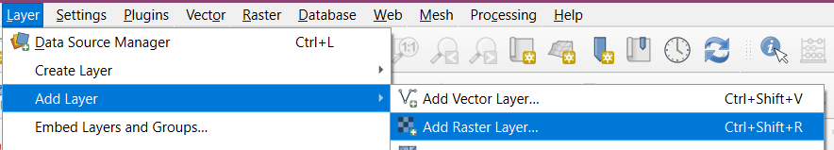

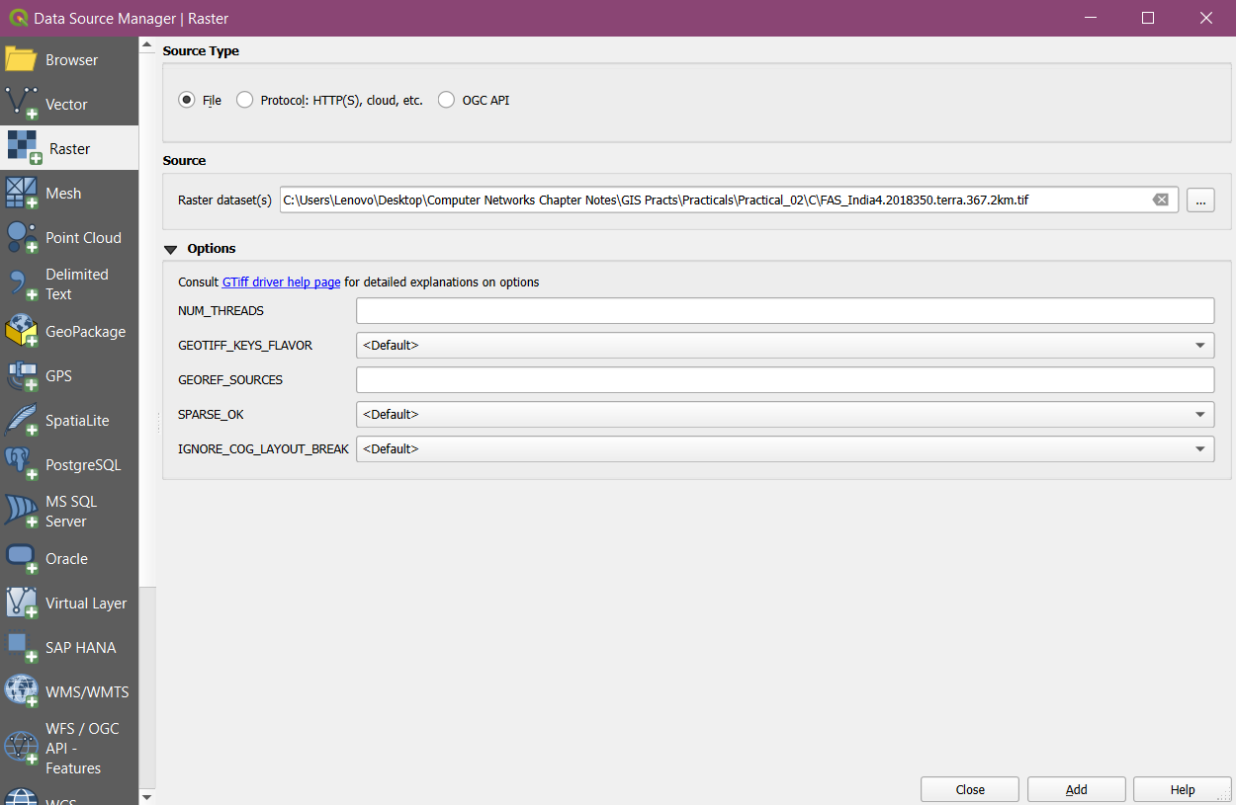

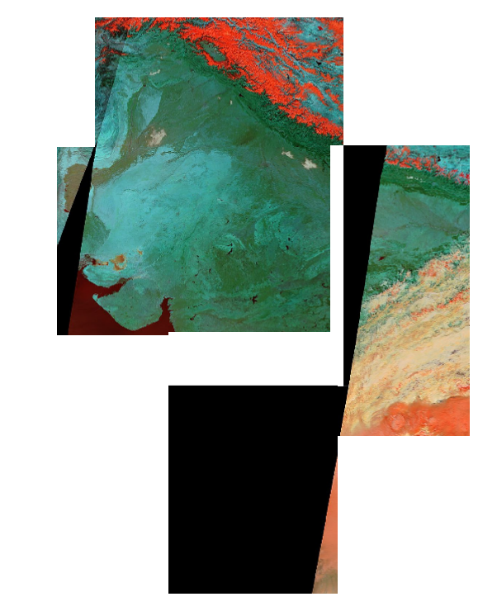

Step 2: Go to Raster → Miscellaneous → Merge. Then select all layers and Press OK. Then select file name and location to save the file.

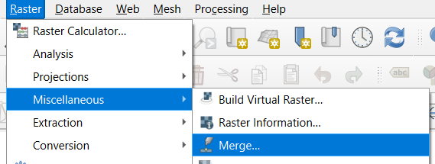

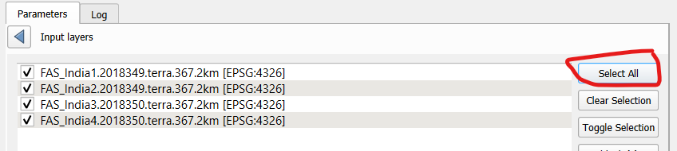
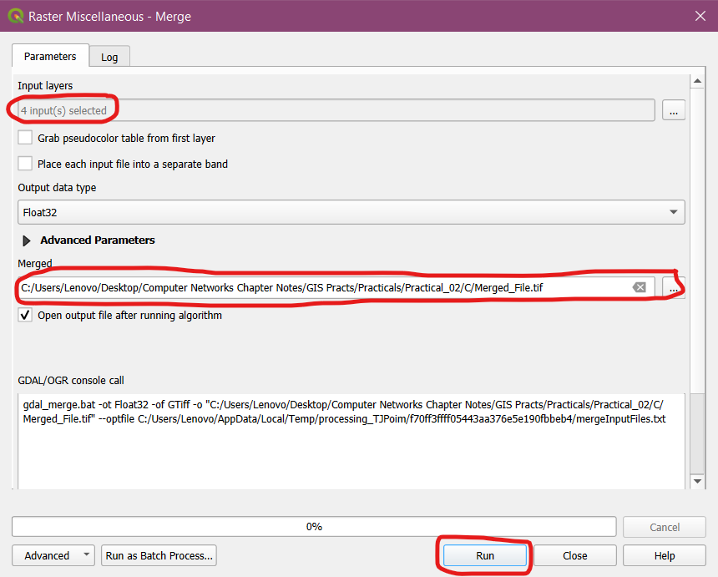

Step 3: Run the file. Then deselect individual layers to see the final output.

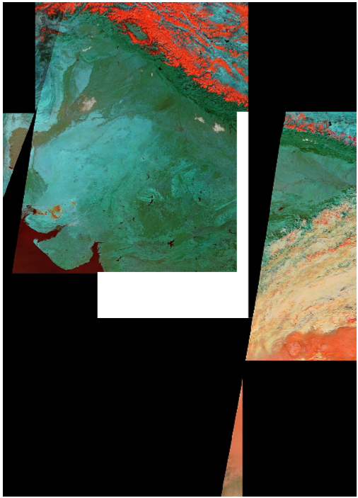

Step 4: Go to Layer → Add Layer → Add Vector Layer. Then Add IND_adm0.shp file. Then double click on the layer → Symbology → Any of the outlines.

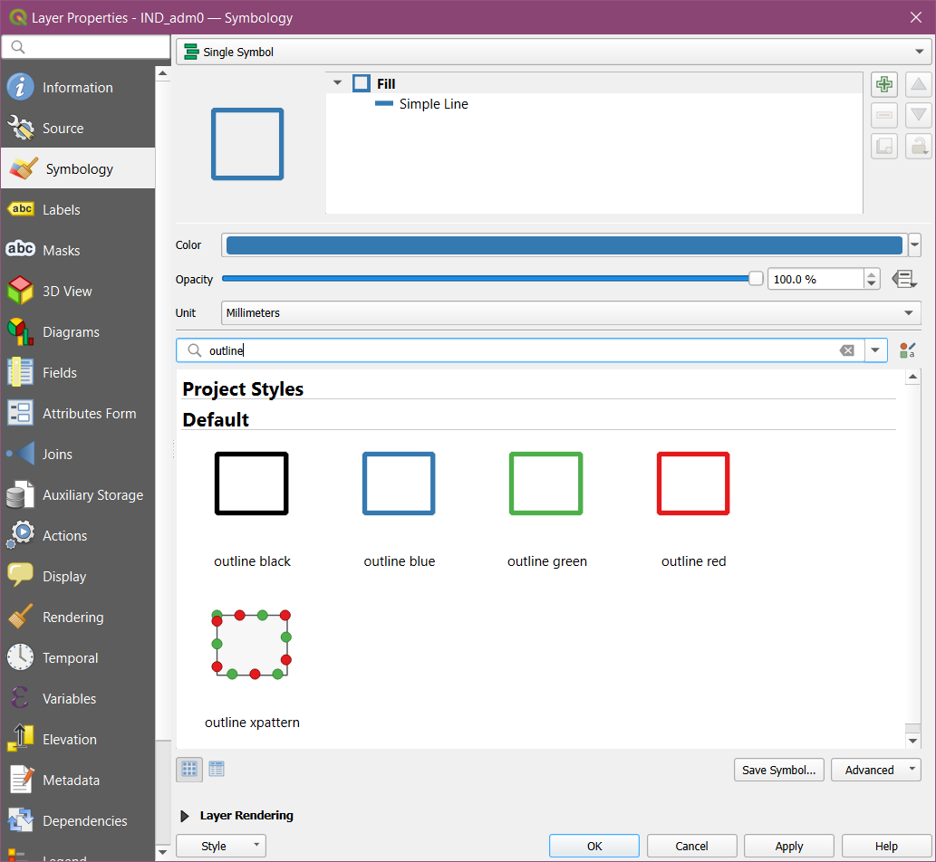

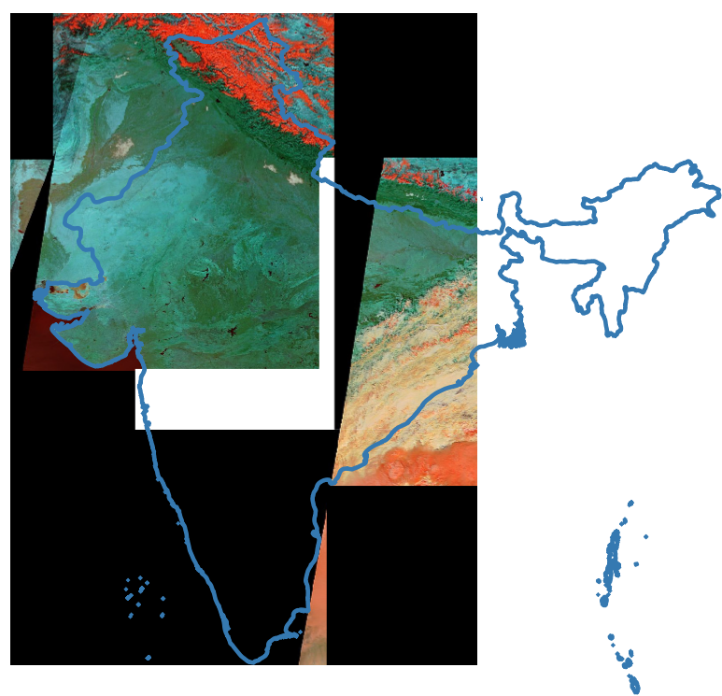

Step 5: Go to Raster → Extraction → Clip Extraction by Mask Layer. Then do the following settings and press run.

